Agile2Learn Scenario

“Project title”

{Author information}

Table of Contents

2 Purpose of the project 3

3 Learning Objectives 3

4 Related Learning Outcomes 3

5 Pre-game 3

5 The game 4

6 Post- game 4

# Purpose of the project

**The purpose of the project is** **………..**

**{describe the purpose of the project}**

# Learning Objectives

In this document, a practical project scenario is provided for those who want to practically apply agile learning at school. The learning objectives are:

{present the learning objectives of the project}

# Related Learning Outcomes

{present expected learning outcomes}

# Pre-game

This phase includes all the all the preparatory steps that should take place before the project implementation begins. These are:

{ you can add or delete according to your needs}

* ***Introduction***: ……
* ***Team Formation*:** …………..
* ***Define the Project***: …….

* ***Project inception:*** ………….
* ***Creation of the project Backlog:*** ………………

# The game

The second or main game phase includes the “Sprint” phase, where is the phase the project is executed. This phase includes:

*Sprint Planning*: ………

*Sprint Execution*: ………

*Dailly sprint: ………………….*

*Sprint Review*: ………………

Note: The acceptance criteria that must be met for a User Story to be accepted as completed have been set by the teacher at the beginning of the project. They reflect the requirements set by the teacher for students during the sprints. At the end of each sprint, the students´ team must demonstrate the relevant knowledge that accumulated during the sprint.

In the Figure below the Scrum process is presented.

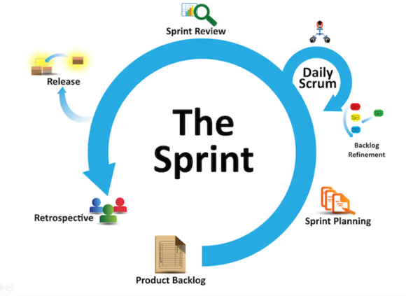

Picture 3: Scrum process

# Post- game

At the third or postgame phase a presentation of the entire project, and a general review (retrospective) take place. It is the phase where each team evaluates its performance, reflects on good or bad practices applied during the previous phases, identify good practices and identify what competences they felt that developed of improved during the Sprints. Specifically, they can focus on:

* What they learned (knowledge related to the subject they dealt with)
* What they learn from the process - collaboration (emphasis on competencies)
* Whether their collaboration improved from Sprint to Sprint
* If not, what was at fault?
* What should have been done?
* What would they like to improve on (competencies)?
* Etc.

The evaluation criteria that we can take into account when applying the agile methods are the following:

* the active engagement
* the successful execution and fulfillment of the objectives
* the ability to solve problems and take initiative.
* the development of social skills (dialogue, communication, collectivity, conflict management, etc.)
* the personal creative expression and integration of each student into the whole transformative learning and changing attitudes
* the evaluation of the results of the project by the students themselves
* etc…

The above is an example outline of how a the specific classroom project can be executed through the implementation of agile methods but it is not the only alternative. Teachers can adjust the previous approach or use their own approach as long as they respect the steps of agile methodologies and follow the guidelines described within the modules offered in the pilot training of Agile2Learn project.